QuickBite food delivery app- web application
User login defect report (Defect Reporting)
Module Name: QuickBite food delivery app-user login defect report(Web)
Test case ID: TC005
Platform: Web application(Responsive)
Login Method: email/mobile + password
Tester Name: VIDHI PATEL
Environment: Windows 10, Google Chrome, QuickBite Version 1.0
Login page
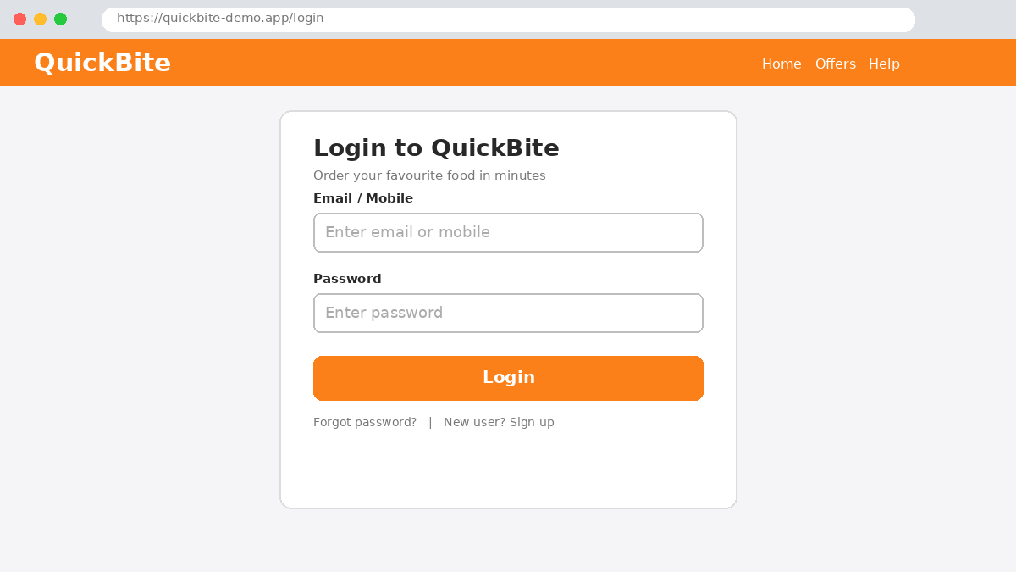
Scenario ID: 1
Scenario: login with valid credentials
Test steps:
- Enter valid email : user@quickbite.com
- Enter valid password : Quick@123
- Click on login
Expected result: Home page with restaurant list is displayed
Actual result: Home page displayed
Status: Pass
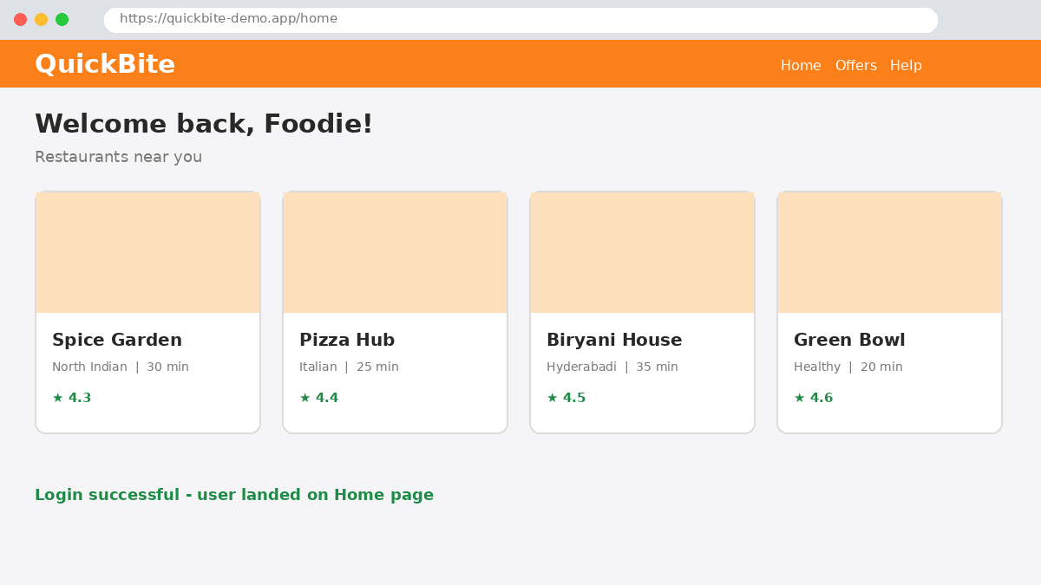
Scenario ID: 2
Scenario: login with valid email and invalid password
Test steps:
- Enter valid email : user@quickbite.com
- Enter invalid password : 12345
- Click on login
Expected result: Error message 'Invalid email or password' is displayed
Actual result: Error message displayed
Status: Pass
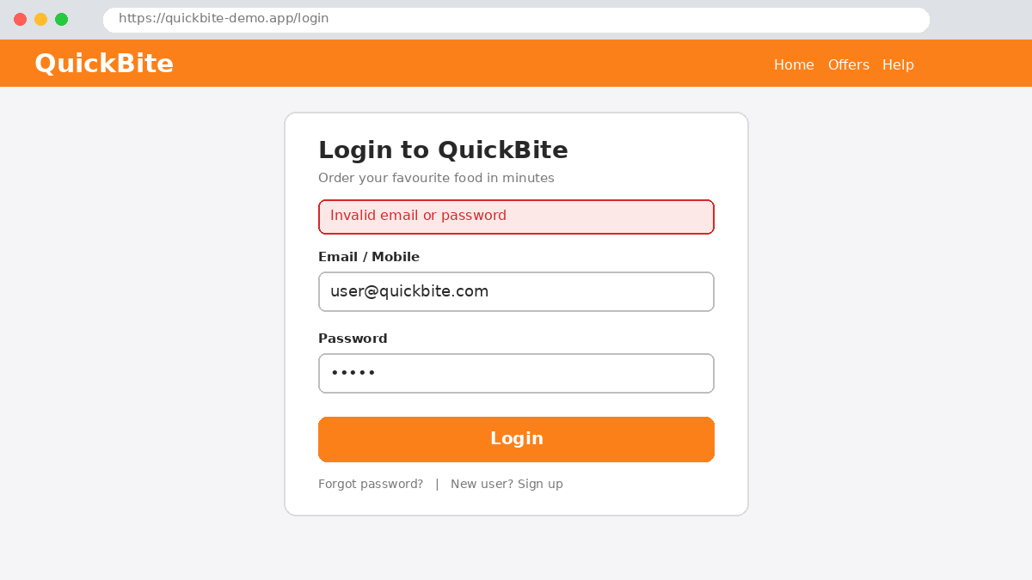
Scenario ID: 3
Scenario: login with invalid email and valid password
Test steps:
- Enter invalid email : student@quickbite.com
- Enter valid password : Quick@123
- Click on login
Expected result: Error message is displayed; no hint about which field is wrong
Actual result: Error message displayed
Status: Pass
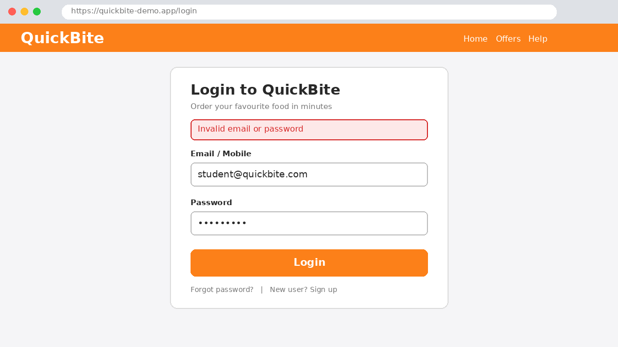
Scenario ID: 4
Scenario: login with both the fields blank
Test steps:
- Enter email : -
- Enter password : -
- Click on login
Expected result: Validation message asks the user to enter email and password
Actual result: No validation message; generic 'Invalid email or password' shown only after submission
Status: Fail Bug ID: BUG-001
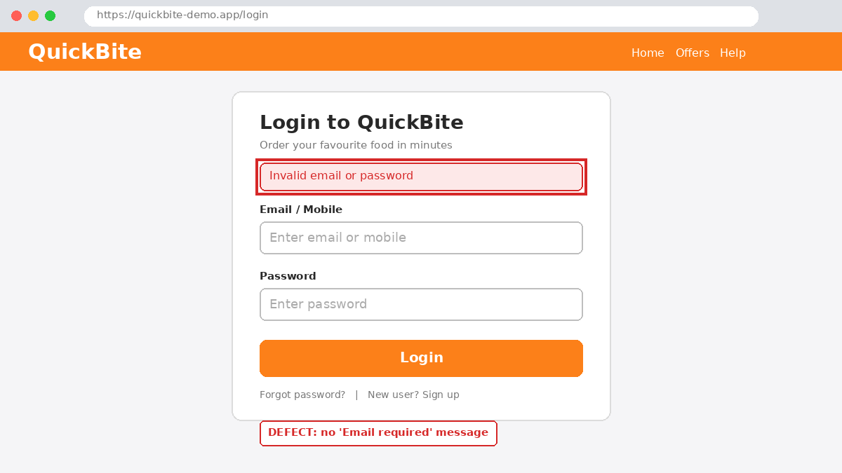
Scenario ID: 5
Scenario: login with valid email and leave the password field blank
Test steps:
- Enter valid email : user@quickbite.com
- Enter password : -
- Click on login
Expected result: Validation message for the password field
Actual result: 'Please fill out this field' displayed
Status: Pass
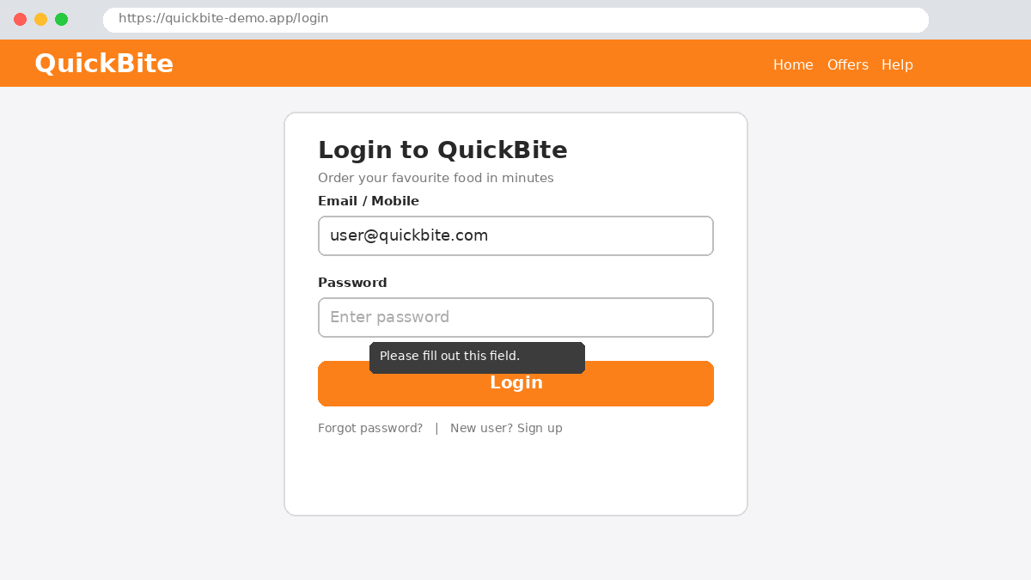
Scenario ID: 6
Scenario: login with valid password and leave the email field blank
Test steps:
- Enter email : -
- Enter valid password : Quick@123
- Click on login
Expected result: 'Email is required' message is displayed
Actual result: No validation message; generic error shown after submission
Status: Fail Bug ID: BUG-001
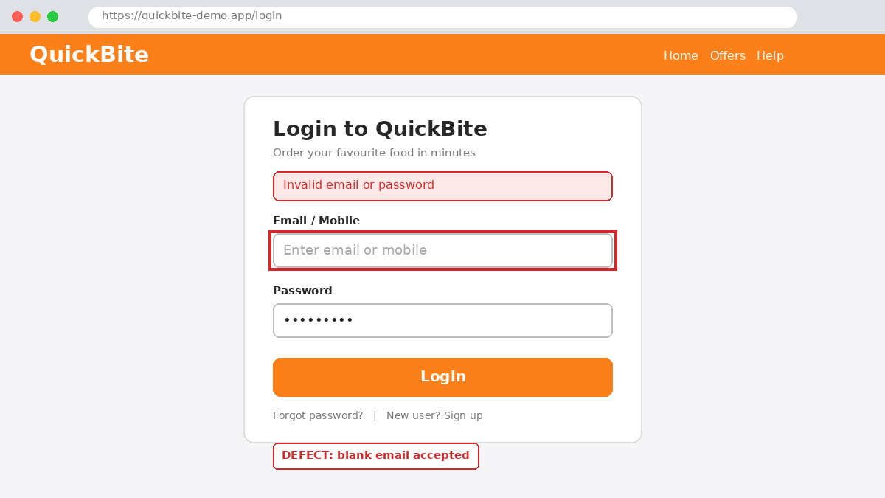
Scenario ID: 7
Scenario: password case sensitivity
Test steps:
- Enter valid email : user@quickbite.com
- Enter password : quick@123
- Click on login
Expected result: Login is rejected because passwords are case sensitive
Actual result: Error message displayed
Status: Pass
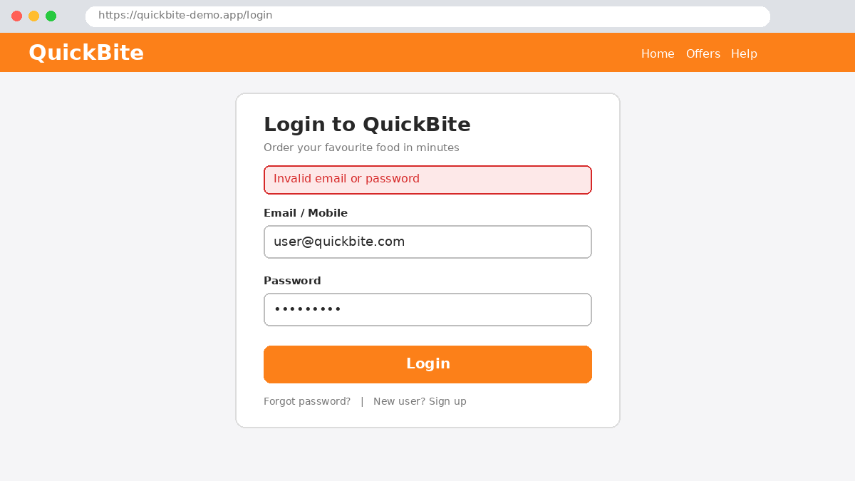
Scenario ID: 8
Scenario: password field is masked
Test steps:
- Enter valid email : user@quickbite.com
- Type password : Quick@123
Expected result: Characters are shown as dots/asterisks
Actual result: Characters are visible in plain text
Status: Fail Bug ID: BUG-002
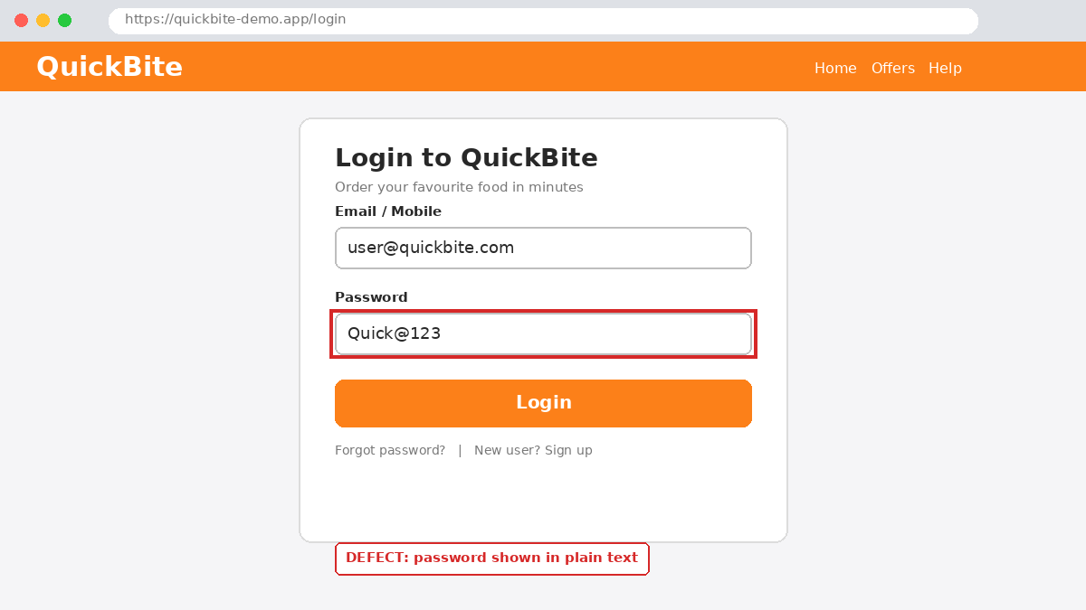
Scenario ID: 9
Scenario: leading/trailing spaces in email
Test steps:
- Enter email with spaces : ' user@quickbite.com '
- Enter valid password : Quick@123
- Click on login
Expected result: Spaces are trimmed and login works
Actual result: Spaces trimmed; Home page displayed
Status: Pass
Scenario ID: 10
Scenario: submit login using Enter key
Test steps:
- Enter valid email : user@quickbite.com
- Enter valid password : Quick@123
- Press Enter
Expected result: Form submits, same as clicking Login
Actual result: Home page displayed
Status: Pass
Scenario ID: 11
Scenario: browser Back button after logout
Test steps:
- Log in successfully
- Click Logout
- Press the browser Back button
Expected result: Protected page is not shown; redirected to login page
Actual result: Login page displayed
Status: Pass
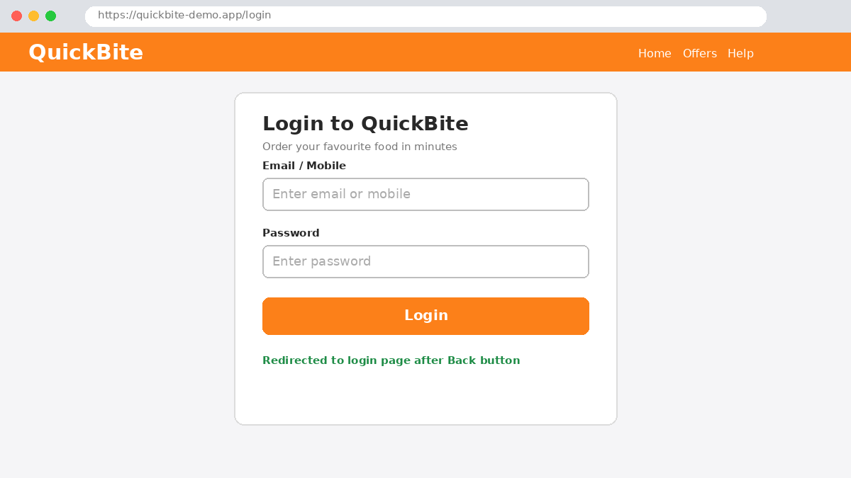

Bug Report
BUG-001 - Login accepts blank email/mobile - validation missing
Field | Details
Bug ID | BUG-001
Bug Summary | Login accepts blank email/mobile - validation missing
Module Name | Login
Severity | Medium
Priority | High
Environment | Windows 10, Google Chrome
Steps to Reproduce | 1. Open the login page  2. Leave Email/Mobile blank  3. Enter password Quick@123  4. Click Login
Expected Result | 'Email is required' message should appear
Actual Result | No validation message appears before the login attempt; generic error shown only after submission
Reported By | VIDHI PATEL
Date Reported | 22/10/2026
Assigned To | Developer
Status | Open
Resolution | Pending
Retest Status | Not Yet Tested
Remarks | Validation needs to be implemented
Screenshot attached:
BUG-002 - Password field not masked - password visible in plain text
Field | Details
Bug ID | BUG-002
Bug Summary | Password field not masked - password visible in plain text
Module Name | Login
Severity | High
Priority | High
Environment | Windows 10, Google Chrome
Steps to Reproduce | 1. Open the login page  2. Enter email user@quickbite.com  3. Type Quick@123 in the Password field
Expected Result | Characters should be shown as dots/asterisks
Actual Result | Typed characters are visible as plain text
Reported By | VIDHI PATEL
Date Reported | 22/10/2026
Assigned To | Developer
Status | Open
Resolution | Pending
Retest Status | Not Yet Tested
Remarks | Security issue: password input type must be hidden
Screenshot attached:
BUG-003 - Cart total not updated after removing an item
Field | Details
Bug ID | BUG-003
Bug Summary | Cart total not updated after removing an item
Module Name | Cart
Severity | Medium
Priority | Medium
Environment | Windows 10, Google Chrome
Steps to Reproduce | 1. Log in and add Paneer Butter Masala and Dal Makhani  2. Remove Dal Makhani  3. Check the Grand Total
Expected Result | Grand Total should update to Rs. 260
Actual Result | Grand Total still shows Rs. 480 until the page is refreshed
Reported By | VIDHI PATEL
Date Reported | 22/10/2026
Assigned To | Developer
Status | Fixed
Resolution | Fixed in build 1.0.1
Retest Status | Passed
Remarks | Verified after fix
Screenshot attached:
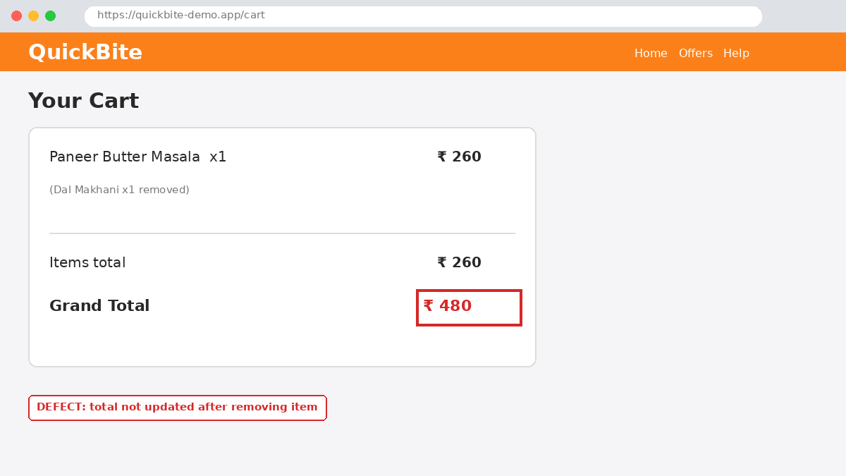
Bug Summary
Bug ID | Module | Severity | Priority | Status
BUG-001 | Login | Medium | High | Open
BUG-002 | Login | High | High | Open
BUG-003 | Cart | Medium | Medium | Fixed

